Problem Statement
A warehouse stores many products. Stock moves in and out every day: new goods arrive (incoming), and goods leave for customers or shops (dispatched). At the end of the period, the stock counted on the shelves (actual closing stock) should match what the records say it should be. If it does not, there is a discrepancy, which could be caused by theft, damage, miscounting or wrong entries. The warehouse also needs to know which products must be re-ordered.
Objectives
- Store each product’s stock data as a tuple in a list.
- Validate the records before processing.
- Calculate the expected closing stock for each product.
- Compare it with the actual closing stock and flag OK, SHORTAGE or SURPLUS.
- Calculate how many units to re-order when stock falls below the reorder level.
- Print a clear reconciliation report and list the invalid records.
Assumptions
- Each record is a tuple: (product, opening, incoming, dispatched, closing_actual, reorder_level, max_level).
- All quantities are whole numbers (units) and cannot be negative.
- Expected closing = opening + incoming − dispatched.
- Difference = actual closing − expected closing. A negative difference is a SHORTAGE, a positive one is a SURPLUS, and zero is OK.
- The allowed tolerance is 0 units by default, so any difference is reported. You can change this.
- Reorder rule: if the actual closing stock is below the reorder level, order enough units to reach the maximum level (max_level − actual stock). Otherwise order nothing.
- A record is invalid if any quantity is not a whole number, if dispatched is more than opening + incoming (you cannot dispatch stock you never had), or if max_level is below reorder_level.
- Invalid records are reported and skipped.
Algorithm
- Define the product records and the tolerance.
- Take the next record.
- Validate it. If it has errors, save the record in the invalid list and move on.
- Calculate the expected closing stock: opening + incoming − dispatched.
- Calculate the difference: actual − expected.
- If |difference| <= tolerance, status is OK. If the difference is negative, it is a SHORTAGE. Otherwise it is a SURPLUS.
- If actual closing stock is below the reorder level, replenishment quantity = max_level − actual. Otherwise it is 0.
- Print the product’s result.
- Repeat for all records, then print the invalid records.
Pseudocode
tolerance = 0

FUNCTION validate_record(rec):
errors = empty list
FOR each quantity in rec:
IF not a whole number OR quantity < 0: add error
IF no errors:
IF dispatched > opening + incoming: add "Dispatched is more than available stock"
IF max_level < reorder_level: add "Max level is less than reorder level"
RETURN errors

FUNCTION find_discrepancy(expected, actual):
diff = actual - expected
IF abs(diff) <= tolerance: RETURN diff, "OK"
IF diff < 0: RETURN diff, "SHORTAGE"
RETURN diff, "SURPLUS"

FUNCTION replenishment_needed(actual, reorder_level, max_level):
IF actual < reorder_level: RETURN max_level - actual
RETURN 0

FUNCTION reconcile_product(rec):
errors = validate_record(rec)
IF errors not empty: RETURN invalid result
expected = opening + incoming - dispatched
diff, status = find_discrepancy(expected, actual)
order = replenishment_needed(actual, reorder, max_level)
RETURN results

MAIN:
FOR each record: reconcile_product(record) and print
print invalid records
Test Cases
# | Test | Input | Expected result
1 | Expected closing | Opening 500, incoming 200, dispatched 450 | 250
2 | Perfect match | Expected 250, actual 250 | Difference 0, OK
3 | Shortage | Expected 250, actual 240 | Difference −10, SHORTAGE
4 | Surplus | Expected 250, actual 260 | Difference +10, SURPLUS
5 | Below reorder level | Actual 40, reorder 100, max 400 | Order 360
6 | Exactly at reorder level | Actual 100, reorder 100, max 400 | Order 0
7 | Just below reorder level | Actual 99, reorder 100, max 400 | Order 301
8 | Zero stock | Actual 0, reorder 10, max 50 | Order 50
9 | Over-dispatch | Opening 10, incoming 5, dispatched 20 | INVALID: dispatched is more than available stock
10 | Max below reorder | Reorder 50, max 20 | INVALID: max level less than reorder level
11 | Bad quantity | Closing = 0.5 or −5 | INVALID: must be a whole number >= 0
12 | Wrong field count | Tuple with 3 fields | INVALID: wrong number of fields
13 | All zeros | Every quantity 0 | Valid, expected 0, OK, order 0

Output
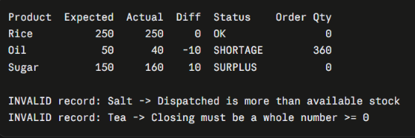
Flowchart
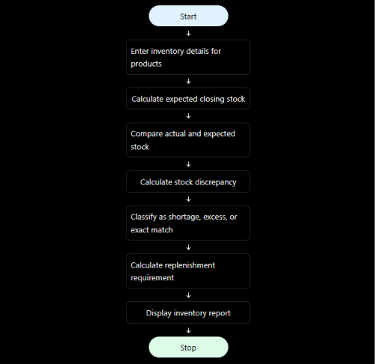
Conclusion
The program compares opening stock, incoming, dispatched and closing stock for several products. It flags discrepancies as SHORTAGE or SURPLUS, rejects impossible records, and calculates how many units to re-order for products running low. In the sample run, Rice matched exactly. Oil had a shortage of 10 units and needs a re-order of 360 units. Sugar had a surplus of 10 units. Salt and Tea were rejected because of bad data (dispatching more than was available, and a negative closing count).

